Incident Briefing (ICS 201)
1. Incident Name:  Global Jet Crash |  | 2. Incident Number:  PANYNJ-16.1313 |  | 3. Date/Time Initiated:  Date: 07/11/16 Time: 1330
4. Map/Sketch
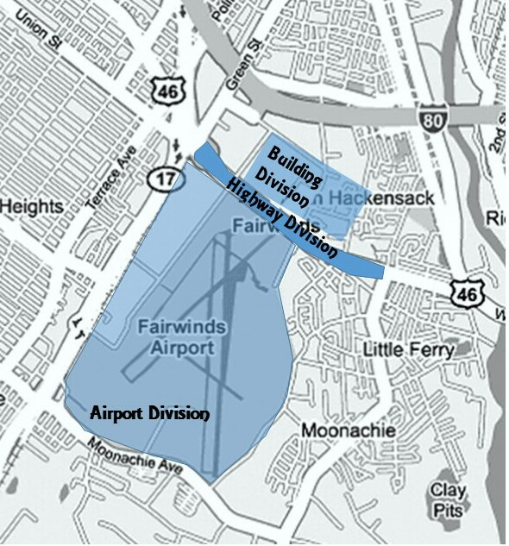
5. Situation Summary and Health and Safety Briefing:
Small executive jet containing 6 passengers and 3 crew owned by Global Investments failed to lift from the runway and crashed through the chain link fence at the end of the airport property. The plane then crossed a major roadway (Route 46), striking four vehicles. It crashed and came to rest inside the adjoining property to the north, which is an office complex with 230 employees for A&C Stores Inc. Fires fueled from the jet’s ruptured tanks erupted at the office complex and in 20 vehicles in the parking lot. Initial response ramped up immediately. We organized as follows (all Divisions & Groups included multi-agency Task Forces, Strike Teams or Single Resources): Building Division included suppressing building and car fires in parking lots, locating & evacuating victims and stabilizing structure while search for victims continues. Highway Division isolated the highway scene, put out the car fires and rescued / triaged /evacuated victims. Airport Division secured the runway scene and assisted the Investigation Group in searching the tarmac for evidence. Traffic Group coordinated re-routing traffic on State highways 17, 46 and I80. Investigation Group worked within Airport, Highway and Building Divisions in identifying, documenting & collecting evidence, coordinated morgue services with the Medical Examiner’s office, and began off-site aircraft/employee records and history examinations.
These initial response actions commenced 07/11/16 at approximately 1330. The initial action resources had a shift change from other agency duty personnel overnight. Those on scene will be relieved at 7/12/16 at 1500 hours by fresh resources under your command. Transfer of Command will occur prior to a 1430 Operational Period Briefing that your IMT3 has been scheduled to conduct. All new incoming resources will be able to arrive no later than 1400 for check-in.
6. Prepared by: Name: RT Gale Position/Title: ICT3 Signature:
 | ICS 201, Page 1 |  | Date/Time: 07/12/16 0900

Incident Briefing (ICS 201)
1. Incident Name:  Global Jet Crash |  | 2. Incident Number:  PANYNJ-16.1313 |  | 3. Date/Time Initiated:  Date: 07/11/16 Time: 1330
7. Current and Planned Objectives:
1-Continually ensure the safety of the public and incident personnel by following appropriate agency guidelines and utilizing a risk assessment and mitigation process prior to engagement in work activities.
2- Expeditiously continue to search for victims in the office structure while concurrently stabilizing the damaged office building and suppressing active fire, with the goal that all viable victims will be rescued alive.
3- Continue to manage re-routing of traffic around accident scene and minimize stakeholder financial and traffic congestion impacts until normal traffic flows can be restored.
4-Complete the accident investigation and maintain incident site perimeter(s) until investigation is completed and incident personnel and public safety is not compromised.
5-Provide accurate and timely information to town and county government, the public, cooperating agencies and stakeholders
6-Assist Global Investments/A&C Stores Inc./Port Authority of NY&NJ in victim and immediate family support and coordinate memorial service to be held on July 13 at 1330 hours.

8. Current and Planned Actions, Strategies, and Tactics:
Time: | Actions:
 | Summary as of 0900, 7/12/16 is as follows:
0900 | Building Division: A head count of 216 people in the office building has been confirmed. Of that 186 people self-evacuated, 16 persons were rescued, 6 were confirmed dead, and 8 are still unaccounted for. 2 of the dead are still trapped in debris. 3 of the dead were in the aircraft that was lodged in the building. Sensors have detected life sounds in the debris. There are still pockets of uncontrolled fire. 75% of the building has been stabilized. Victims were transported to Hackensack University Medical Center and Mt Sinai St Lukes Medical Center.
0900 | Highway Division: All car fires are extinguished. The investigation has been completed in this area, and resources will complete documentation by 1300 today. There are 66 abandoned cars, 20 cars with moderate damage and 12 cars with severe damage along ¾ mile of 4 lane highway 46. Once documentation is completed the area must be cleared of vehicles and debris.
0900 | Airport Division: The investigation is complete on the runway and in facilities used to manage air traffic, aircraft servicing and passenger access and support. The runway can be re-opened, but a TFR is still in place to reduce air traffic over the scene and for the safety of incident aviation resources.
0900 | Investigation Group: Investigation/documentation is still ongoing and additional resources to expand the investigation have been ordered. Resources are primarily working in the Building Division, but there are aspects of investigation still ongoing in the Airport and Highway divisions. The Bergen County Medical Examiner’s Office established a temporary morgue at the Bergen Regional Medical Center near their office in Paramus, NJ.
0900 | Traffic Group: Traffic will need to be re-routed around the Highway Division until at least 07/13/16 1400 hours.
 | Planned memorial service: Agency Representatives of the airport, Global Investments and A&C Stores have requested IMT support of a memorial service they have planned for July 13 at 1330 hours.
 | At the present time Global Investments and A&C Stores have both been providing transportation, lodging and peer support to victims and families, but have been operating independently.
6. Prepared by: Name: RT Gale Position/Title: ICT3 Signature:
ICS 201, Page 2 |  |  | Date/Time: 07/12/16 0900

Incident Briefing (ICS 201)
1. Incident Name:  Global Jet Crash | 2. Incident Number:  PANYNJ-16.1313 |  | 3. Date/Time Initiated:  Date: 07/11/16 Time: 1330
9. Current Organization: As of 07/12/16 at 0900 this is the current organization
Traffic Group
NJSP

Investigation Group
PANYNJ

Supply Unit Leader
Fire Dept
Medical Unit Leader
Fire Dept
Safety Officer
Fire Department
Public Information Officer
PANYNJ
Agency Representative(s)
PANYNJ-Airport Manager
NJ State Police-Captain
Airport Division
PANYNJ
Highway Division
Police Dept
Building Division
Fire Dept
Operations Section Chief
Fire Dept
Resource Unit Leader
NJSP
Logistics Section Chief
Fire Dept
Time Unit Leader
PANYNJ
Incident Commander(s)

Fire Department

Police Department (Deputy)
6. Prepared by: Name: Don Palmer Position/Title: RESL Signature:
ICS 201, Page 3 |  | Date/Time: 07/12/16 0845

Incident Briefing (ICS 201)
1. Incident Name:  Global Jet Crash |  | 2. Incident Number:  PANYNJ-16.1313 |  |  |  |  | 3. Date/Time Initiated:  Date: 07/11/16 Time: 1330
10. Resource Summary:
Resource | Resource Identifier | Date/Time Ordered |  | ETA | Arrived | Notes (location/assignment/status)
US&R Task Force Type 3 | NY-TF1 | 07/12/16 0800 |  | 1300 |  | Ordered for Building Division
LE Strike Team Type 4  (NJ State Police) | NJ-NJS-2 | 07/12/16 0800 |  | 1300 |  | Ordered for Traffic Group
LE Strike Team Type 4  (PANYNJ) | NY-PATH-12 | 07/12/16 0800 |  | 1340 |  | Ordered to supplement Investigation Group
NTSB Partial Field Team | NJ-NTSB | 07/12/16 0800 |  | 1200 |  | Ordered to supplement Investigation Group
Critical Incident Stress Mngmt Team Type 2 | NY-PATH | 07/12/16 0800 |  | 1330 |  | Ordered to provide victim/family assistance
Fire Engine Type 1 – Hasborough Heights VFD | NJ-HHE1 | 07/12/16 0800 |  | 1300 |  | Ordered for assignment where needed
Heavy Rescue Unit Hasborough Heights VFD | NJ-HHR1 | 07/12/16 0800 |  | 1300 |  | Ordered for assignment where needed
Fire Engine Type 1 – Moonachie VFD | NJ-MVFD | 07/12/16 0800 |  | 1300 |  | Ordered for assignment where needed
Fire Engines Type 1-  Hackensack Eng 302, 303, 305 | NJ-HFD | 07/12/16 0800 |  | 1330 |  | Ordered for assignment where needed
Ladder 306  Hackensack FD | NJ-HFD | 07/12/16 0800 |  | 1330 |  | Ordered for assignment where needed
LE Strike Team Type 4  (PANYNJ) | NY-PATH-6 | 07/12/16 0840 |  | 1300 |  | Ordered for Incident Security to work for Logistics
Incident Management Team Type 3 | NY-NYS | 07/12/16 - 0400 |  | 0930 | X | Includes all Command & General Staff members & RESL, SITL, 4 DIVS
22 Tow Trucks | Local vendors | 07/12/16 0800 |  | 1330 |  | Ordered for assignment where needed
14 Flat Bed Trucks | Local vendors | 07/12/16 0800 |  | 1330 |  | Ordered for assignment where needed
2 Type 3 Hydraulic Excavators | Local vendor | 07/12/16 0800 |  | 1330 |  | Ordered for assignment where needed
Ambulance Type 1 = 3  Ambulance Type 2 = 3 | Mutual Aid | 07/12/16  0800 |  | 1300 |  | Total six mutual aid ambulances and EOC says all ambulance orders will be filled.
Task Force Leader = 6 | Mutual Aid | 07/12/16  0830 |  | 1400 |  | Total Six ordered, and EOC says all TFLD orders will be filled in time for briefing.
6. Prepared by: Name: Don Palmer Position/Title: RESL Signature:
ICS 201, Page 4 |  |  | Date/Time: 07/12/16 0845

