INCIDENT ACTION PLAN

I 400

ICS FOR MAJOR/COMPLEX INCIDENTS
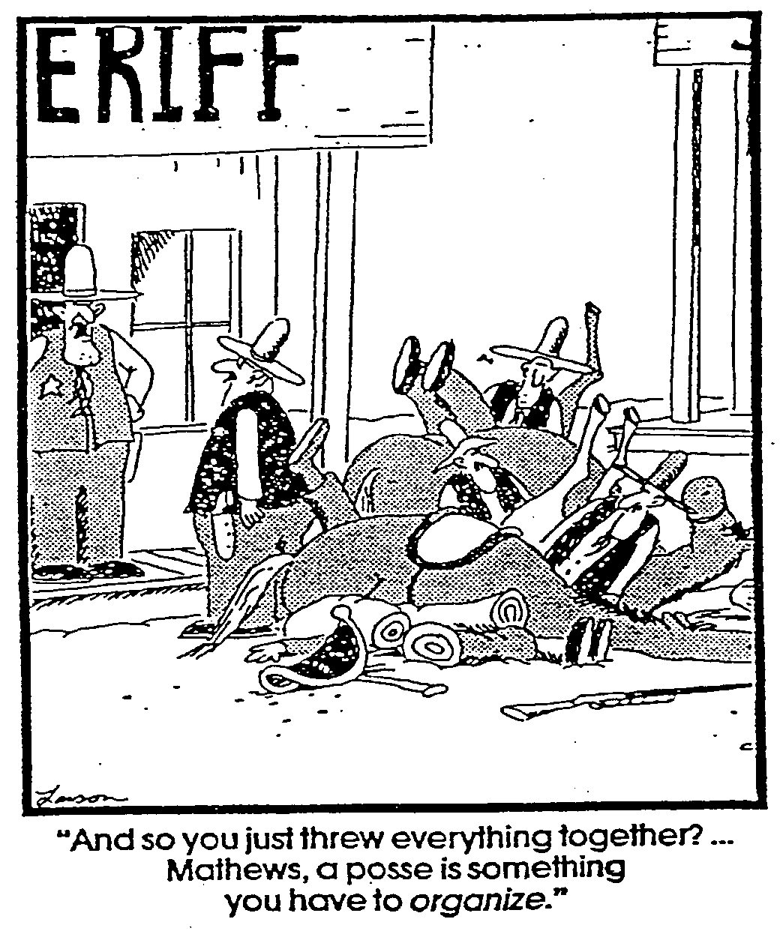

JUNE 19-20, 2019
SUFFOLK COUNTY
RIVERHEAD, NY


Electronic Copy of Class IAP

Incident Objectives (ICS 202)
1. Incident Name: SUFFOLK I400 |  | 2. Operational Period: Date From: 06/19/19 Date To: 06/20/19  Time From: 0730 Time To: 1700
3. Objective(s):

1-Provide a safe and comfortable classroom environment and if an emergency occurs that impacts the classroom or training facility ensure accountability of all incident personnel.

2- Ensure all Unit instructional objectives of the national ICS400 curriculum are met as documented by 100% of students successfully passing the final course exam administered on June 20, 2019.

3-Return Incident Facilities to clean and orderly condition at completion of incident
4-Provide documentation of course completion to NYOEM by submitting completed final exams, student registration materials and instructor time and travel to NYOEM by June 24, 2019.

4. Operational Period Command Emphasis:
This is a course about the ICS processes used on very large scale and long duration incidents. Some of the concepts are used frequently on large scale incidents, while some of the concepts and methods are only rarely used. Most students may have a limited background on these large scale / long duration incidents, so it is valuable for students to allow themselves to be open to new concepts.
General Situational Awareness : Weather forecast
Wednesday 06/19: Cloudy with showers. High near 70F. Winds E at 5 to 10 mph. Chance of rain 40%. Overnight mostly cloudy. Low 61F. Winds light and variable.

Thursday 06/20: Mostly cloudy in the morning then periods of showers later in the day. Thunder possible. High 74F. Winds ESE at 5 to 10 mph. Chance of rain 40%. Overnight cloudy with showers. Low 63F. Winds SE at 5 to 10 mph. Chance of rain 50%.

5. Site Safety Plan Required? Yes No X
Approved Site Safety Plan(s) Located at:
6. Incident Action Plan (the items checked below are included in this Incident Action Plan):
X ICS 203 ICS 207 Other Attachments:
X ICS 204 ICS 208 X ICS 214 Activity Log
ICS 205 Map/Chart
ICS 205A Weather Forecast/Tides/Currents
ICS 206
7. Prepared by: Name: Bob Panko Position/Title: DPIC T4 Signature: 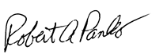
8. Approved by Incident Commander: Name: Robert Panko Signature: 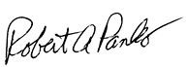
ICS 202 | IAP Page __2___ |  | Date/Time: 06/17//19 0905

ORGANIZATION ASSIGNMENT LIST (ICS 203)
1. Incident Name: SUFFOLK I400 |  |  | 2. Operational Period: Date From: 06/19/19 Date To: 06/20/19 Time From: 0730 Time To: 1700
 |  |  |  |  | 7. Operations Section:
IC/UCs | Chris Lieberman (917-280-4998) |  |  |  | Chief
Deputy IC | Bob Panko (305-323-1385) |  |  |  | Deputy
 |  |  |  |  | Staging Area
Safety Officer |  |  |  |  | Branch
Public Info. Officer |  |  |  |  | Branch Director
Liaison Officer |  |  |  |  | Deputy
4. Agency/Organization Representatives: |  |  |  |  | Task Force Ldr
Agency/Organization |  |  |  |  | Task Force Ldr
Northwell Health |  | Danton Kerz (631) 566-8320 |  |  | Group
NYS OEM |  | John Thomsen (518-292-2361) |  |  | Division/Group
 |  |  |  |  | Division/Group
 |  |  |  |  | Branch
 |  |  |  |  | Branch Director
 |  |  |  |  | Deputy
5. Planning Section: |  |  |  |  | Division/Group
Chief |  |  |  |  | Division/Group
Deputy |  |  |  |  | Division/Group
Resources Unit |  |  |  |  | Division/Group
Situation Unit |  |  |  |  | Division/Group
Documentation Unit |  |  |  |  | Branch
Demobilization Unit |  |  |  |  | Branch Director
Technical Specialists |  |  |  |  | Deputy
 |  |  |  |  | Division/Group
6. Logistics Section: |  |  |  |  | Division/Group
Chief |  |  |  |  | Division/Group
Deputy |  |  |  |  | Air Operations Branch
Support Branch |  |  |  |  | Air Ops Branch Dir.
Director
Supply Unit
Facilities Unit |  |  |  |  | 8. Finance/Administration Section:
Ground Support Unit |  |  |  |  | Chief
Service Branch |  |  |  |  | Deputy
Director |  |  |  |  | Time Unit
Communications Unit |  |  |  |  | Procurement Unit
Medical Unit |  |  |  |  | Comp/Claims Unit
Food Unit |  |  |  |  | Cost Unit
9. Prepared by: Name: Bob Panko Position/Title: DPIC T4 Signature:
ICS 203 |  | IAP Page __3___ |  | Date/Time: 06/17/19 0905

ASSIGNMENT LIST (ICS 204)
1. Incident Name:  SUFFOLK I400 |  |  | 2. Operational Period:  Date From: 06/19/19 Date To: 06/19/19  Time From: 0730 Time To: 1700 |  |  |  | 3.  Branch: 1  Division: 1  Group: 1  Staging Area: 1
4. Operations Personnel: Name Contact Number(s)
Operations Section Chief:
Branch Director:
Division/Group Supervisor:
5. Resources Assigned: |  |  |  | # of  Persons |  | Scheduled Times | Reporting Location, Special Equipment and Supplies, Remarks, Notes, Information
Resource Identifier | Leader |  |  |  |  | Scheduled Times
UNIT 1-COURSE OVERVIEW | Bob Panko |  |  |  |  | 0800-0830 | DP1
UNIT 2-ICS REVIEW FOR C&G | Chris Lieberman |  |  |  |  | 0830-1130 | DP1
UNIT 3-MAJOR INC MNGT | Bob Panko |  |  |  |  | 1230-1630 | DP1
6. Work Assignments:
IC/DPIC will prep room and ensure all A/V equipment is functional and course materials are on hand starting at 0730.
Assign Area Command USCG article as “homework” or break time reading.

Module Leaders to provide 10 min break each hour.
Students will prepare Activity Logs at end of the day and submit to IC.

7. Special Instructions:

Be sure to check if students can leave their materials in classroom overnight and advise students of outcome.

8. Communications (radio and/or phone contact numbers needed for this assignment):
Name/Function Primary Contact: indicate cell, pager, or radio (frequency/system/channel)
/
/
/
/
9. Prepared by: Name: Bob Panko Position/Title: DPIC T4 Signature:
ICS 204 |  | IAP Page __4___ |  |  | Date/Time: 06/17/19 0930

ASSIGNMENT LIST (ICS 204)
1. Incident Name:  SUFFOLK I400 |  |  | 2. Operational Period:  Date From: 06/20/19 Date To: 06/20/19  Time From: 0730 Time To: 1700 |  |  |  | 3.  Branch: 1  Division: 1  Group: 1  Staging Area: 1
4. Operations Personnel: Name Contact Number(s)
Operations Section Chief:
Branch Director:
Division/Group Supervisor:
5. Resources Assigned: |  |  |  | # of  Persons |  | Scheduled Times | Reporting Location, Special Equipment and Supplies, Remarks, Notes, Information
Resource Identifier | Leader |  |  |  |  | Scheduled Times
OP Briefing | Bob Panko |  |  |  |  | 0800-0830 | DP1
UNIT 4-AREA COMMND | Bob Panko |  |  |  |  | 0830-1130 | DP1
UNIT 5-MULTI AGENCY COORD | Chris Lieberman |  |  |  |  | 1230-1430 | DP1
UNIT 6-SUMMARY / EXAM | Bob Panko |  |  |  |  | 1430-1600 | DP1
6. Work Assignments:

IC/DPIC will prep room and ensure all A/V equipment is functional and course materials are on hand starting at 0730.

Students will complete NYSOEM Course Evaluation and submit to IC for review and submission to NYSOEM Training Division.
7. Special Instructions:

8. Communications (radio and/or phone contact numbers needed for this assignment):
Name/Function Primary Contact: indicate cell, pager, or radio (frequency/system/channel)
/
/
/
/
9. Prepared by: Name: Bob Panko Position/Title: DPIC T4 Signature:
ICS 204 |  | IAP Page __5___ |  |  | Date/Time: 06/17/19 0910

Activity Log (ICS 214)
1. Incident Name: SUFFOLK I400 |  |  | 2. Operational Period: Date From: 06/19/19 Date To: 06/20/19  Time From: Time To:
3. Name: |  | 4. ICS Position:  STUDENT |  |  | 5. Home Agency (and Unit):
6. Resources Assigned:
Name |  | ICS Position |  |  | Home Agency (and Unit)
NOTE: THIS FORM IS BEING USED
SOLELY AS A METHOD OF
GATHERING STUDENT INPUT
INTO THE PRESENTATIONS.
PLEASE LET US KNOW WHAT YOU
THINK. THESE INPUTS ARE ONLY
FOR THE INSTRUCTORS!
7. Activity Log:
Date/Time | Notable Activities
 | SUMMARIZE IN YOUR OWN WORDS
 | 1-INSTUCTOR EFFECTIVENESS
 | 2-USE OF VISUAL AIDS
 | 3-COURSE MATERIAL
 | 4-EFFECTIVENESS OF PRACTICAL EXERCISES
 | 5-CLASSROOM SETTING
 | 6-OTHER COMMENTS
 | (YOU ARE NOT OBLIGATED TO SIGN THE FORM IF YOU WANT TO BE ANONYMOUS)
8. Prepared by: Name: Position/Title: Signature:
ICS 214, Page 6 |  |  |  | Date/Time:

