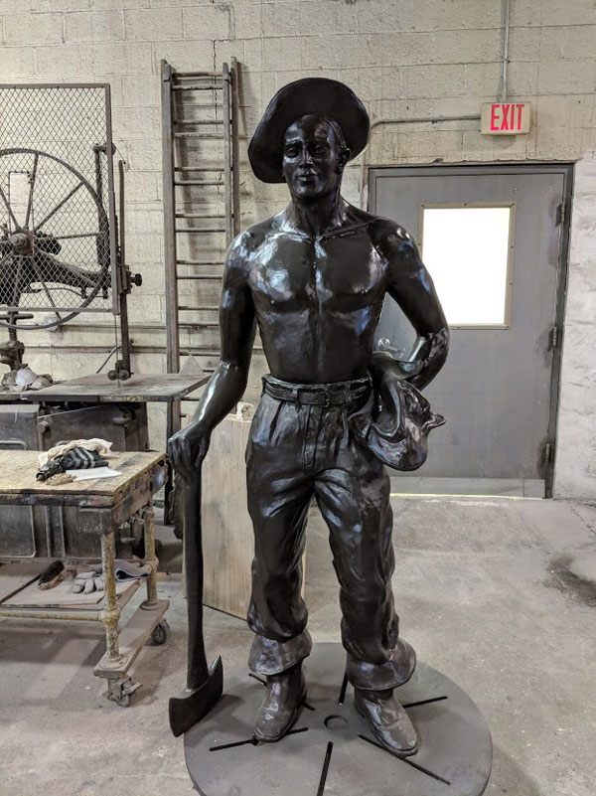  pachaug state forest ccc statue unveiling | event action plan SEPTEMBER 21, 2019  DEEP Dispatch  #860-424-3333
  CONNECTICUT DEPT OF ENERGY & ENVIRONMENTAL PRO TECTION | FRIENDS OF PACHAUG FOREST INC.

Incident Objectives (ICS 202)
1. Incident Name:  PSF CCC STATUE UNVEILING |  | 2. Operational Period: Date From: 09/21/19 Date To: 09/21/19  Time From: 0700 Time To: 1600
3. Objective(s):
1-Assure the safety of Forest visitors, event participators and event staff by monitoring weather conditions for threats, providing assistance to people with special needs, maintaining effective emergency transportation routes, separating pedestrian and vehicle traffic and effectively communicating / directing event activities throughout the duration of the Event.
2-Provide quality activities for this unveiling ceremony that include public speakers, live music, a variety of foods and educational opportunities about the CCC and civic and municipal service organizations that are stakeholders of Pachaug State Forest.
3-Provide on-site public safety assistance and first responder capability to mitigate any injuries or threats.
4-Provide bug repellant to public and event participants.
5-Confine event activities to the specific sites being used in Pachaug State Forest to minimize impacts of the event on other Forest visitors and assure the areas used for the event are cleaned and restored to pre-event condition by 1600 hours on 09/21/19.

4. Operational Period Command Emphasis:
Summary of events
0800 Supervisors Briefing
0800-0900 Set up commences in all Groups. Exhibitors & food trucks begin to open for attendees
1000 Event officially begins. Attendees visit Food trucks & exhibitors. Audience seating opens.
1100 Ceremony Commences at Dais/Podium and Seating Areas
1200 Unveiling of Statue
1220-1400 Attendees talk with CCC vets, presenters, exhibitors and visit food trucks.
1400 Event Closes
1600 Breakdown and Clean Up completed.

General Situational Awareness
The public is very aware that testing has found that mosquitos bearing the Eastern Equine Encephalitis virus have been collected at a sample site in a swamp in PSF near this event. As a result CT DEEP closed both the Mt. Misery Campground and Frog Hollow Horse Camp in July. DEEP however has NOT closed any PSF areas to DAYTIME USE. While mosquitos can be present during the day, especially in damp and shady areas, CT. health advisories direct people to limit outside exposure between dusk and dawn. Use insect repellent. Refer to CT DEEP advisory on EEE and mosquito bite prevention
5. Site Safety Plan Required? Yes No X
Approved Site Safety Plan(s) Located at:
6. Incident Action Plan (the items checked below are included in this Incident Action Plan):
X ICS 203 ICS 207 Other Attachments:
X ICS 204 X ICS 208
ICS 205 X Maps
ICS 205A X Weather Forecast
X ICS 206
7. Prepared by: Name: Bob Panko Position/Title: Unified Event Com. Signature: 
8. Approved by Incident Commander: Name: Signature:
ICS 202 | IAP Page ___1__ |  | Date/Time:

ORGANIZATION ASSIGNMENT LIST (ICS 203)
1. Incident Name:  PSF CCC STATUE UNVEILING |  |  | 2. Operational Period: Date From: 09/21/19 Date To: 09/21/19  Time From: 0700 Time To: 1600
3. Incident Commander(s) and Command Staff: |  |  |  |  | 7. Operations Section:
Unified Commanders | Mark Darin (CT DEEP) 860-803-1592 |  |  |  | Chief
 | Bob Panko (FOPF) 305-323-1385 |  |  |  | Deputy
Deputy |  |  |  |  | Staging Area
Safety Officer |  |  |  |  |  | Group Supervisor
Public Info. Officer | Bobbie Cornelius FOPF (860)931-4675 |  |  |  | Presentation Group | Ryan Snide FOPF | #860-639-8719
Public Info.Asst. | Shawn Hill FOPF (860) 591-9203 |  |  |  | Parking Group | Mark Darin, DEEP | 860-803-1592
4. Agency/Organization Representatives: |  |  |  |  | Public Safety Group | Bob Panko FOPF | 305-323-1385
Agency/Organization |  | Name |  |  | Exhibitors Group | Alison Joslyn FOPF | 860-857-2134
FOPF |  | Sharon Viadella (860) 303-7320 |  |  | Food Truck Group | Jesse Gay FOPF | #860-303-9075
DEEP |  | Tom Tyler (860) 242-3099
 |  |  |  |  | Branch
 |  |  |  |  | Branch Director
 |  |  |  |  | Deputy
5. Planning Section: |  |  |  |  | Division/Group
Chief |  |  |  |  | Division/Group
Deputy |  |  |  |  | Division/Group
Resources Unit |  |  |  |  | Division/Group
Situation Unit |  |  |  |  | Division/Group
Documentation Unit |  |  |  |  | Branch
Demobilization Unit |  |  |  |  | Branch Director
Technical Specialists |  |  |  |  | Deputy
 |  |  |  |  | Division/Group
 |  |  |  |  | Division/Group
 |  |  |  |  | Division/Group
6. Logistics Section: |  |  |  |  | Division/Group
Chief |  | Mike Lane FOPF 860-861-5404 |  |  | Division/Group
Logistics Crew |  | Tom Gaudreau FOPF |  |  | Air Operations Branch
 |  | Dennis Snide FOPF
 |  | Renee B.
 |  | Ian Snide |  |  | 8. Finance/Administration Section:
 |  | Ellis T |  |  | Chief | Susan Lane FOPF (860)-334-9075
 |  |  |  |  | Deputy
Food Unit |  |  |  |  | Cost Unit
9. Prepared by: Name: Bob Panko Position/Title: Unified Event Comm Signature:
ICS 203 |  | IAP Page ___2__ |  | Date/Time:

OVERALL EVENT MAP

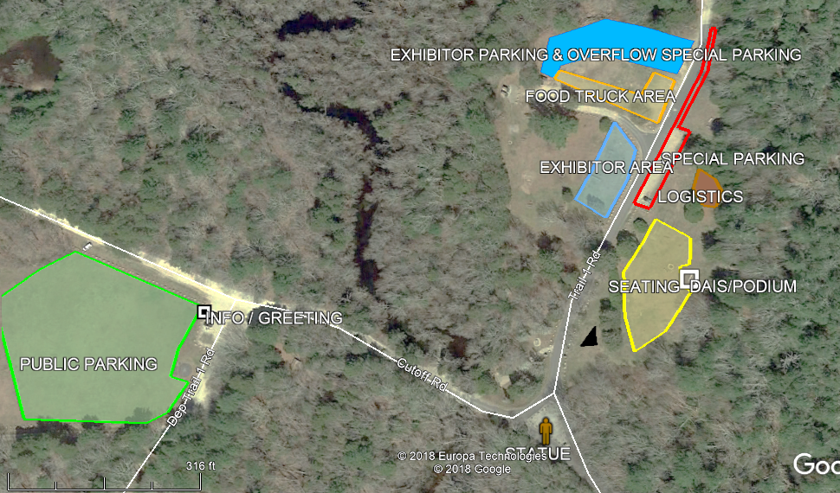

WEATHER FORECAST:

Sunny. High 83F. Winds NW at 5 to 10 mph becoming light and variable

ASSIGNMENT LIST (ICS 204)
1. Incident Name:  PSF CCC STATUE UNVEILING |  |  | 2. Operational Period:  Date From: 09/21/19 Date To: 09/21/19  Time From: 0700 Time To: 1600 |  |  |  | 3.  1  INFORMATION & GREETING 1
4. Public Information Personnel:  Name Contact Number(s)  Public Information Officer Bobbi Cornelius FOPF (860)931-4675  Public Information Asst: Shawn Hill FOPF (860) 591-9203 |  |  |  |  |  |  | 3.  1  INFORMATION & GREETING 1
5. Resources Assigned: |  |  |  | # of  Persons |  | Contact (e.g., phone, pager, radio frequency, etc.) | Reporting Location,
Resource Identifier | Leader |  |  |  |  | Contact (e.g., phone, pager, radio frequency, etc.) | Reporting Location,
Info / Greeting Tent | Bobbi Cornelius |  |  |  |  |  | Supv Briefing 0730
6. Work Assignments:
Set up and staff an Information Booth (pop up, table and displays) at the NE corner of Chapman Field (right where FOPF usually sets up). Use poster board displays to describe the event activities and times and also have a map display of the event sites.

Lists should also highlight Food Trucks on site as well as what groups have displays in the Exhibitor area.

Have various kinds of bug spray on hand and allow people to apply it (don’t hand out containers, let them use it).

Shawn Hill to rove for social media coverage, taking pictures, and maybe doing live casts. Hill will also video the presentation and unveiling for FOPF documentation.

7. Special Instructions:
Coordinate set up and take down assistance with the Logistics section chief Mike Lane.

PIO Bobbi will also be available to work with any media crews that might come to the event. Meeting place for media to report to would be the Info/Greeting tent at Chapman Field. As needed Mark Darin can also be called over to be interviewed or assist the media.

If Info / Greeting tent is swamped with visitors Bobbi should contact Panko who can determine who is available and reassign them to help out Bobbi.
9. Prepared by: Name: Position/Title: Signature:
ICS 204 |  | IAP Page __4___ |  |  | Date/Time:

ASSIGNMENT LIST (ICS 204)
1. Incident Name:  PSF CCC STATUE UNVEILING |  |  | 2. Operational Period:  Date From: 09/21/19 Date To: 09/21/19  Time From: 0700 Time To: 1600 |  |  |  | 3.  1  LOGISTICS SECTION
4. Public Information Personnel:  Name Contact Number(s)  Logistics Section Chief Mike Lane FOPF 860-861-5404 |  |  |  |  |  |  | 3.  1  LOGISTICS SECTION
5. Resources Assigned: |  |  |  | # of  Persons |  | Contact (e.g., phone, pager, radio frequency, etc.) | Reporting Location,
Resource Identifier | Crewmember |  |  |  |  | Contact (e.g., phone, pager, radio frequency, etc.) | Reporting Location,
Logistics Crew | Tom Gaudreau FOPF |  |  | 1 |  |  | Logistics Area 0800
 | Dennis Snide FOPF |  |  | 1 |  |  | Logistics Area 0800
 | Renee B. FOPF |  |  | 1 |  |  | Logistics Area 0800
 | Ian Snide FOPF |  |  | 1 |  |  | Logistics Area 0800
 | Ellis Tucker FOPF |  |  | 1 |  |  | Logistics Area 0800
Golf Carts | Drivers as designated |  |  | 2
6. Work Assignments:
Logistics will provide all the stuff we need to the people who need it as well as provide assistance in setting up and taking down tents, tables, etc. as requested. Logistics will set up behind the Special Parking area as designated on the map to be centrally located.

Logistics will also manage and staff the Golf Carts that are to be used to transport people needing assistance from parking areas to other Event locations. Coordinate with Parking Group Supv Mark Darin.
7. Special Instructions:
Logistics will have on hand an assortment of supplies and materials. They include but are not limited to:
Logistics trailer to haul supplies and equipment, 6 pop up canopies, 12 folding chairs, assorted outdoor power cords and power strips, Generator (Sharon), Generator (Ryans friend), coordinate use of DEEP generator, portable sound system (&or coordinate with Wolverine Radio), cases of bottled water for event staff, bug spray for event staff and for public to spray on, poster boards and markers for making signs, assorted hand tools and battery powered tools, coolers, duct tape, etc.

It is also recommended to have some 2x4’s and some 2x2 sheets of 3/8 inch plywood for any sign fabrication needs.
9. Prepared by: Name: Position/Title: Signature:
ICS 204 |  | IAP Page __5__ |  |  | Date/Time:

ASSIGNMENT LIST (ICS 204)
1. Incident Name:  PSF CCC STATUE UNVEILING |  |  | 2. Operational Period:  Date From: 09/21/19 Date To: 09/21/19  Time From: 0700 Time To: 1600 |  |  |  | 3.  1  Group:  PRESENTATION GROUP  1
4. Operations Personnel: Name Contact Number(s)  Group Supervisor: Ryan Snide |  |  |  |  |  |  | 3.  1  Group:  PRESENTATION GROUP  1
5. Resources Assigned: |  |  |  | # of  Persons |  | Contact (e.g., phone, pager, radio frequency, etc.) | Reporting Location,
Resource Identifier | Leader |  |  |  |  | Contact (e.g., phone, pager, radio frequency, etc.) | Reporting Location,
CT DEEP Program Emcee | Tom Tyler |  |  | 1 |  |  | Dais/Podium 1030
Wolverine Radio | Mike Minarsky |  |  | 1 |  | 860-710-8119 | Dais/Podium 0800
CCC Troubadour | Tom Callinan |  |  | 1 |  | 860-889-6648 | Dais/Podium 1030
Presenters: | Snide/Somers/Hanson  Lanoue/Courtney/Babbitt  Podskosh/Oehler/Caruso  Viadella |  |  | 10 |  |  | Dais/Podium 1045
Vtown Scout Troop #74 | Erin |  |  | 7 |  | Will be the Color Guard | Seating Area 0800
National Anthem | Jack Donahue |  |  | 1 |  | Will sing the National Anthem | Dias/Podium 1045
6. Work Assignments:
Group Supervisor Snide to coordinate set up of Dais/Podium area including sound system setup with Wolverine Radio, chairs for presenters, and connections to generators. Assistance can be coordinated with Logistics. Wolverine Radio will set up 0800 and be doing live broadcast and audience music show until presentation begins and the use speakers for audience. Troubadour will need to report at 1030 for sound check.
DEEP Tom Tyler will be the presentation master of ceremonies for the presentation and will introduce the list of speakers in whatever sequence as decided by Viadella/Tyler prior to show.
Group Supv will also meet up with and coordinate Scout Troop 74 in setting up and taking down the audience chairs in the event seating area.

7. Special Instructions:
Snide family to provide chairs for audience seating.
The actual ceremony will begin 1100 hours and last about 1 hour.
Presenters will walk to Statue triangle for unveiling about 1200. (CCC gents need golf cart transport)
It may be difficult for all spectators to crowd into the area for the unveiling, and portable sound system may be needed.
Traffic Management (Darin) will close road to traffic for the unveiling.
9. Prepared by: Name: Position/Title: Signature:
ICS 204 |  | IAP Page __6___ |  |  | Date/Time:

ASSIGNMENT LIST (ICS 204)
1. Incident Name:  PSF CCC STATUE UNVEILING |  |  | 2. Operational Period:  Date From: 09/21/19 Date To: 09/21/19  Time From: 0700 Time To: 1600 |  |  |  | 3.  1  Group:  PARKING & TRAFFIC GROUP 1  1
4. Operations Personnel: Name Contact Number(s)  Group Supervisor: Mark Darin 860-803-1592 |  |  |  |  |  |  | 3.  1  Group:  PARKING & TRAFFIC GROUP 1  1
5. Resources Assigned: |  |  |  | # of  Persons |  | Contact (e.g., phone, pager, radio frequency, etc.) | Reporting Location, Special Equipment and Supplies, Remarks, Notes, Information
Resource Identifier | Leader |  |  |  |  | Contact (e.g., phone, pager, radio frequency, etc.)
Special & Exhibitors Parking | Kacy Nash |  |  | 3 |  | (860) 213-1816 | Briefing @0800 NE Corner Exhibitor Field
Chapman Field Parking | Jay Nisbet |  |  | 4 |  | (860) 710-6067 | Briefing @0800 NE Corner Exhibitor Field
Traffic Management | Mark Darin |  |  | 1 |  | 860-803-1592 | Briefing @0800 NE Corner Exhibitor Field
Kubota
6. Work Assignments:
Mark Darin will supervise the Parking Crew and Traffic Management function. He will have Kacy Nash (+2 seasonals) and Jay Nisbet (+3 seasonals) working for him.

Parking Crew is responsible for directing parking in the Public Parking lot (Chapman Field) and the Exhibitor and Special Parking lots (Group camp area Trail 1 parking). See maps for parking configurations.

Traffic Management: Mark Darin will be stationed at the entrance road intersection with the Triangle and will direct traffic to the appropriate parking area. Exhibitor and Special Parking Passes have been provided in advance to some of those persons authorized to park in those lots to expedite arrival.
7. Special Instructions:
Darin will work with Logistics crew to cone pedestrian and one-way vehicle lanes between the Triangle and Chapman Field. Access to the site from Stone Hill Rd / Trail 1 will be closed off.

Unified Incident Commander Mark Darin will also directly lead this Group.
8. Communications (radio and/or phone contact numbers needed for this assignment):
Name/Function Primary Contact: indicate cell, pager, or radio (frequency/system/channel)
/
/
/
/
9. Prepared by: Name: Position/Title: Signature: 
ICS 204 |  | IAP Page __7___ |  |  | Date/Time:

ASSIGNMENT LIST (ICS 204)
1. Incident Name:  PSF CCC STATUE UNVEILING |  |  | 2. Operational Period:  Date From: 09/21/19 Date To: 09/21/19  Time From: 0700 Time To: 1600 |  |  |  | 3.  Group: 1  Public Safety Group
4. Operations Personnel: Name Contact Number(s)  Group Supervisor: Bob Panko 305-323-1385 |  |  |  |  |  |  | 3.  Group: 1  Public Safety Group
5. Resources Assigned: |  |  |  | # of  Persons |  | Contact (e.g., phone, pager, radio frequency, etc.) | Reporting Location, Special Equipment and Supplies, Remarks, Notes, Information
Resource Identifier | Leader |  |  |  |  | Contact (e.g., phone, pager, radio frequency, etc.)
EMS  VTown VFD 2 EMT’s | TBD |  |  | 2 |  |  | Briefing @0800 NE Corner Exhibitor Field
Law Enforcement | ENCON Jason Williams |  |  | 1 |  |  | Briefing @0800 NE Corner Exhibitor Field
Drone Pilot VFD  . | Ryan Hargraves |  |  | 1 |  |  | Briefing @0800 NE Corner Exhibitor Field
6. Work Assignments:
This Groups focus is:
- Provide emergency medical assistance to public and event personnel (VTown VFD);
- Provide law enforcement coverage (Interagency Law Enforcement Task Force).

Drone: Flight missions DO NOT IMPACT THE CEREMONY visually or audibly.

7. Special Instructions:
Unified IC Bob Panko will coordinate with the single resources listed above in this Group.
9. Prepared by: Name: Position/Title: Signature:
ICS 204 |  | IAP Page __8___ |  |  | Date/Time:

ASSIGNMENT LIST (ICS 204)
1. Incident Name:  PSF CCC STATUE UNVEILING |  | 2. Operational Period:  Date From: 09/21/19 Date To: 09/21/19  Time From: 0700 Time To: 1600 |  |  |  | 3.  1  Group: 1  Exhibitors Group
4. Operations Personnel: Name Contact Number(s)  Group Supervisor: Allison Joslyn 860-857-2134 |  |  |  |  |  | 3.  1  Group: 1  Exhibitors Group
5. Resources Assigned: |  |  | # of  Persons |  | Contact (e.g., phone, pager, radio frequency, etc.) | Reporting Location, Special Equipment and Supplies, Remarks, Notes, Information
Resource Identifier | Leader |  |  |  | Contact (e.g., phone, pager, radio frequency, etc.)
Voluntown Historical Society | Jen Panko |  | 4 |  | 305-281-5022 cell | Exhibitors Area 0800
Friends of Pachaug Forest | Sue Lane |  | 2 |  | 860-334-9075 | Exhibitors Area 0800
FOPF Arts & Crafts | Lauren Churchill & Ellis Tucker |  | 2 |  | 860-455-8642 | Exhibitors Area 0800
Marty Podskoch | Marty Podskoch |  | 1 |  |  | Exhibitors Area 0800
The Last Green Valley | TBD |  | ? |  |  | Exhibitors Area 0800
Voluntown Economic Dev Comm | Jack Wesa |  | 2 |  | 860-961-0977 | Exhibitors Area 0800
Voluntown Volunteer Booth | Judith Allik |  | 1
Live Music | Jonny Debit |  | 1 |  | 860-849-6490 | NE corner of Exhibitors Field after unveiling
6. Work Assignments:
Exhibitors (stakeholders, cooperators and friends) can set up tables/tents in the Exhibitor field starting at 0800. Exhibitors should place their tents/tables along the Eastern edge of the Exhibitor Field (just behind the rocks along Trail 1).
Voluntown Historical Society will be giving away ice cream and baked goods.
Exhibitors will clean up their area and vacate by 1400 hours. Their quitting time is at their discretion.
Jonny Debit will set up in NE corner of this field and will provide live music post ceremony,

7. Special Instructions:
Sale of merchandise is prohibited unless special permission is provided by CT DEEP, however donations may be accepted.
Monitor for trash issues and remove trash to dumpsters as needed.

8. Communications (radio and/or phone contact numbers needed for this assignment):
Name/Function Primary Contact: indicate cell, pager, or radio (frequency/system/channel)
/
/
/
/
9. Prepared by: Name: Position/Title: Signature:
ICS 204 | IAP Page ___9__ |  |  | Date/Time:

ASSIGNMENT LIST (ICS 204)
1. Incident Name:  PSF CCC STATUE UNVEILING |  |  | 2. Operational Period:  Date From: 09/21/19 Date To: 09/21/19  Time From: 0700 Time To: 1600 |  |  |  | 3.  1  Group: Food Truck Group 1
4. Operations Personnel: Name Contact Number(s)  Group Supervisor: Jesse Gay |  |  |  |  |  |  | 3.  1  Group: Food Truck Group 1
5. Resources Assigned: |  |  |  | # of  Persons |  | Contact (e.g., phone, pager, radio frequency, etc.) | Reporting Location, Special Equipment and Supplies, Remarks, Notes, Information
Resource Identifier | Leader |  |  |  |  | Contact (e.g., phone, pager, radio frequency, etc.)
Craven Haven | John Foucault |  |  |  |  | 860-993-5491 | Food Truck Area 0800
Roadside Grill | Rob Tynan |  |  |  |  | 860-439-1851 | Food Truck Area 0800
Brick & Basil | John |  |  |  |  | 860-889-9663 | Food Truck Area 0800
Green Valley Cotton Candy | TBD |  |  |  |  | 860-576-5535 | Food Truck Area 0800
6. Work Assignments:
Food Truck Group Supervisor Jesse Gay will direct food trucks where to park and oversee operations at the Food Truck area. The vendors can start setting up at 0800 and can remain on scene if desired until 1400 hours.

Craven Haven to be parked at the SE corner of the Food Vendor Field and additional food trucks should be placed along the South edge of the field. Refer to map.

7. Special Instructions:
If vendors trucks are using generators try to position them to minimize noise to other event areas adjacent to them. Monitor for trash issues and remove trash to dumpsters as needed.
8. Communications (radio and/or phone contact numbers needed for this assignment):
Name/Function Primary Contact: indicate cell, pager, or radio (frequency/system/channel)
/
/
/
/
9. Prepared by: Name: Position/Title: Signature:
ICS 204 |  | IAP Page __10___ |  |  | Date/Time:

Medical Plan (ICS 206)
1. Incident Name:  PSF CCC STATUE UNVEILING |  |  |  |  | 2. Operational Period: Date From: 09/21/19 Date To: 09/21/19  Time From: 0700 Time To: 1600
3. Medical Aid Stations:
Name |  |  | Location |  |  |  |  | Contact Number(s)/Frequency |  |  | Paramedics  on Site?
Voluntown VFD EMT’s |  |  | Chapman Field |  |  |  |  | Contact on site |  |  | Yes X No
 |  |  |  |  |  |  |  |  |  |  | Yes No
 |  |  |  |  |  |  |  |  |  |  | Yes No
 |  |  |  |  |  |  |  |  |  |  | Yes No
4. Transportation (indicate air or ground):
Ambulance Service |  |  | Location |  |  |  |  | Contact Number(s)/Frequency |  |  | Level of Service
Voluntown VFD |  |  | Voluntown Fire Station |  |  |  |  | 911 or mobilized by on site EMT’s |  |  | ALS X BLS
 |  |  |  |  |  |  |  |  |  |  | ALS BLS
 |  |  |  |  |  |  |  |  |  |  | ALS BLS
 |  |  |  |  |  |  |  |  |  |  | ALS BLS
5. Hospitals:
Hospital Name | Address,  Latitude & Longitude  if Helipad |  |  | Contact Number(s)/ Frequency |  |  | Travel Time |  |  | Trauma Center | Burn Center | Helipad
Hospital Name |  |  |  |  |  |  | Air |  | Ground | Trauma Center | Burn Center | Helipad
Backus Hospital | 326 Washington St, Norwich, CT 06360 |  |  |  |  |  |  |  | 30 | X Yes  Level:___1__ | Yes No | Yes No
Plainfield Healthcare Center | 31 Dow Rd, Plainfield, CT 06374 |  |  |  |  |  |  |  | 25 | Yes  Level:_____ | Yes No | Yes No
Day Kimball Hospital | 320 Pomfret St, Putnam, CT 06260 |  |  |  |  |  |  |  | 45 | Yes  Level:_____ | Yes No | Yes No
Pachaug Animal Hospital | 156 Preston City Road (Rte 165), Voluntown CT |  |  |  |  |  |  |  | 10 | Yes  Level:_____ | Yes No | Yes No
6. Special Medical Emergency Procedures:
Voluntown VFD providing EMTs on site. VFD will follow its standard procedures and protocols for response and augmentation of resources as needed including Life Flight.

In absence of VFD all medical emergencies will be handled by calling 911.
Check box if aviation assets are utilized for rescue. If assets are used, coordinate with Air Operations.
7. Prepared by (Medical Unit Leader): Name: Signature:
8. Approved by (Safety Officer): Name: Signature:
ICS 206 |  | IAP Page __12___ |  |  |  | Date/Time:

Safety Message/Plan (ICS 208)
1. Incident Name:  PSF CCC STATUE UNVEILING |  |  | 2. Operational Period: Date From: 09/21/19 Date To: 09/21/19  Time From: 0700 Time To: 1600
3. Safety Message/Expanded Safety Message, Safety Plan, Site Safety Plan:

THUNDERSTORMS/INCLEMENT WEATHER: A spot weather forecast for this Event will be requested on Sept 20 to cover the 21st to provide expanded situational awareness. On the 21st Command will monitor weather for advance notice of thunderstorms or other inclement weather that may affect the Event.
-In the event of thunderstorms the 30-30 rule will be followed:
- 30 Seconds: Count the seconds between seeing lightning and hearing thunder. If this time is less than 30 seconds, lightning is a threat. ... 30 Minutes: After hearing the last rumble of thunder, wait 30 minutes before leaving shelter. If necessary to shelter all persons will be asked to shelter in place in their vehicles.
-Extreme Heat; keep hydrated. Water is provided to event staff. Visitors should be encouraged to obtain water from Food Trucks.

EEE: Mosquitos bearing the Eastern Equine Encephalitis virus have been detected in this area. Use mosquito repellant; avoid shade and marshy areas; insect repellant is available for free.

EMERGENCY ACCESS ROUTES: Traffic Management team (VFD Fire Police) will keep emergency lanes open as much as possible. During the unveiling the roads near the Statue triangle will be closed to vehicles, but alternative access/exit routes via Trail 1 (to the West) and Stone High Road (to North & East) will be available (see Wide View Map). In the event that additional emergency personnel must access the site (e.g. American Paramedic Ambulance) Traffic Management team will send a member to the major road access point to direct these resources to the scene.

VEHICLES AND PEDESTRIANS: We want to keep vehicles and pedestrians apart! Traffic Management Team (VFD Fire Police) may cone out pedestrian walkways adjacent to active roads and alternate one-way traffic on the narrowed roadway. Traffic Management Team to wear reflective vests.

SLIPS / TRIPS: It’s a Forest. Keep alert for areas to trip or slip, especially if you are carrying items.

POWER CORDS & GROUNDS: Flag or cover power cords. Establish circuits on GFI’s if possible. Ground generators before use.

4. Site Safety Plan Required? Yes No
Approved Site Safety Plan(s) Located At:
5. Prepared by: Name: Position/Title: Signature:
ICS 208 |  | IAP Page __13___ |  | Date/Time:

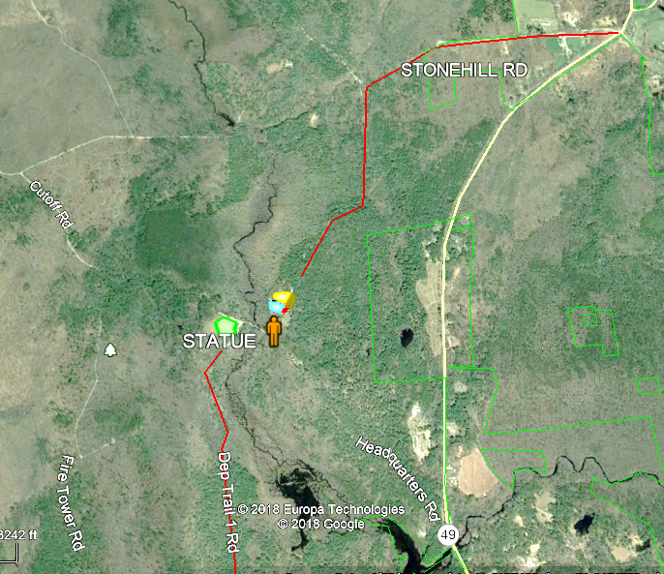
STONE HILL RD AND TRAIL 1 ACCESS ROUTES

Activity Log (ICS 214)
1. Incident Name:  PSF CCC STATUE UNVEILING |  |  | 2. Operational Period: Date From: 09/21/19 Date To: 09/21/19  Time From: 0700 Time To: 1600
3. Name: |  | 4. ICS Position: |  |  | 5. Home Agency (and Unit):
6. Resources Assigned:
Name |  | ICS Position |  |  | Home Agency (and Unit)
7. Activity Log:
Date/Time | Notable Activities
8. Prepared by: Name: Position/Title: Signature:
Page 15 |  |  |  | Date/Time:

